14th Annual Dinner and Auction
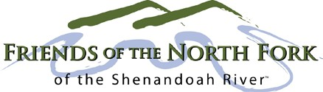

Woodstock Moose Lodge
Saturday, October 13, 2018
5:30 - 9:00 pm

Thank you for supporting our work to protect the North Fork of the Shenandoah. Your sponsorship is critical to our efforts. We hope to see you on October 13th for a festive evening benefitting the river!

To become a sponsor, please mail your check, made out to FNFSR, along with the form below to:
FNFSR P.O. Box 746 Woodstock, VA 22664

Credit Card payments: fnfsr.org/donate

-----------------------------------------------------Dinner & Auction Sponsorship Form------------------------------------------------

Yes! We would like to sponsor the Annual Dinner at the following level:

Level | Donation | #of  Tickets
 | Amount | Tickets

_____ | $2,500 | 8
___ Diamond* | $1,000 | 6
 | $500 | 4
 | $250 | 2

We are unable to sponsor this year but would like to make a donation of $

Name: _________________________________________________________

Guests: ________________________________________________________

Address:

City: State:
Zip:

Telephone:
Email:

